

NCIA – National Cancer Imaging Archive

Software Design Description

Release 2.3 – Integration with Cedara Visualization Software



Document Change Record
Version Number | Date | Description
1.0 | 03/09/07 | Initial document

TABLE OF CONTENTS
1 Introduction 1
1.1. PROJECT BACKGROUND 1
1.2 SYSTEM OVERVIEW 1
2 Use Cases 2
3 System Architecture 3
4 configuration 4
4.1 NCIA.PROPERTIES 4
4.2 Add new servlet filter to web.xml 4
4.3 FACES-CONFIG.XML and tiles.xml 4
5 Sequence diagrams 5
5.1 Integration with cedara visualization tool 5
6 Components 6
6.1 USER INTERFACE 6
6.1.1 Visualization Images Page 6
6.2 Cedara Image Grid Server(IGs) 7
6.2.1 Example 7
6.3 User interface Backing Beans 8
6.3.1 Search Result Bean 8
6.3.2 NCIAConfig class 8
6.4 MIDDLE TIER 9
6.4.1 ImageServlet 9
6.5 BACK END 9
6.5.1 Domain Classes 9
6.5.2 Database Design 9
6.5.3 Views 9
6.5.4 Indexes 9

Introduction
The purpose of this document is to describe the design for the Integration with Cedara Visualization Tool feature being developed for Release 2.3 of the NCIA – National Cancer Imaging Archive software.
The enhancement will provide new functionality to allow users to view images (series) using Cedara Visualization Software.

PROJECT BACKGROUND
Please refer to the NCIA Architecture Overview for background on the NCIA project.

SYSTEM OVERVIEW
Please refer to the NCIA Architecture Overview for a system overview.
.

Use Cases
Please refer to use case document and diagram for this enhancement.

System Architecture

configuration

NCIA.PROPERTIES
The following new properties are added to ncia.properties file.
#cedara frontier address - http.frontier@address
http.frontier@address=137.187.66.21

#cedara frontier port - http.frontier@port
http.frontier@port=8888

#cedara I-Response workstation address
irw_address=http://localhost:8889

Add new servlet filter to web.xml
A new servlet is being added to listen to the request from Cedara Image Grid Server. It validates user credentials and returns the DICOM file pathes requested. For the servlet to run, it must be configured in web.xml. The following will be added to web.xml:
<servlet>
<servlet-name>ImageServlet</servlet-name>
<servlet-class>gov.nih.nci.ncia.viewer.ImageServlet</servlet-class>
</servlet>

<servlet-mapping>
<servlet-name>ImageServlet</servlet-name>
<url-pattern>/ImageList</url-pattern>
</servlet-mapping>

cedara IGS joex.exe.properties
The following properties need to be set accordingly
provider@service.endpoint = http://165.112.132.35:49080/ncia/ImageList
http.frontier@address = 137.187.66.21
http.frontier@port = 8888

Sequence diagrams
For some use cases, sequence diagrams are helpful to illustrate the execution flow. Sequence diagrams are included this section for the appropriate use cases. Details of the objects that participate in the use cases are described in section.

Integration with cedara visualization tool
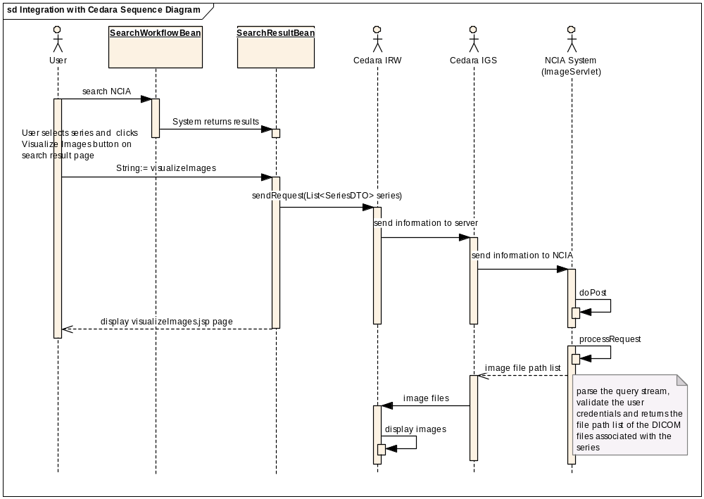

Components

USER INTERFACE
A link/button will be added to the search result page (Study level). This button is only showed for results coming from local node.
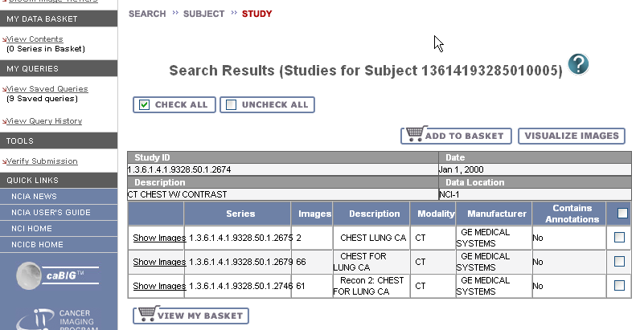
New java script method, sendReqToCedaraIRW is created to process and submit the request to Cedara I-Response Workstation running in local machine when the “VISUALIZE IMAGES” button is clicked. The request is submitted in the following format:
http://localhost:8889/(&usr=value&uid=value&host=value)

Cedara Image Grid Server(IGs)
IGS is responsible for constructing a link to NCIA containing the parameters. The link must be built as follows:
[http,https]://[server:port]/ncia/ImageList?{paramName=paramValue}
The protocol, server and port will vary depending on the NCIA instance being linked to. The parameters passed are as follows:
Parameter | Description | Validations
usr | The user Id for the user who wants to view image with Cedara software | Required – occurs only once
uid | Image series ID | Required – occurs many times

Any characters that need to be escaped (such as whitespace) must be properly escaped by the referencing application as described at http://java.sun.com/j2se/1.5.0/docs/api/java/net/URLEncoder.html.

Example
https://imaging.nci.nih.gov/ncia/ImageList?uid=1.2.840.113704.1.111.1029.1002282906.1 &uid=1.2.840.113704.1.111.1029.1002282906.1 &usr=foo

User interface Backing Beans

Search Result Bean
The Search Result Bean will be modified to add the following fields, methods for this enhancement.
New Fields/Methods | Type | Description
getIsIRWAvailable() | Boolean | This method will try to connect to local Cedara IRW and returns “true” if it is running, otherwise it returns “false”
getHost() | String | Get the IGS server information from config file and return it as a String.
getUser() | String | Return the current username as a String
getIsLocalNode() | Boolean | This method will check whether the result is from local node search and returns “true”; otherwise, returns “false”. The purpose of this method is to show the “VISUALIZE IMAGES” button on the searchStudy.jsp page when the return is true.

NCIAConfig class
The following methods will be added to this class to get the values from ncia.properties file
New Method | Type | Description
getCedaraIGSAddress() | String | Return address of Cedara server (IGS)
getCedaraIGSPort() | String | Return port of IGS
getCedaraIRWAddress() | String | Return address of Cedara I-Response Workstation (IRW)
getCedaraIRWPort() | String | Return port of the Cedara IRW

MIDDLE TIER

ImageServlet
A servlet class named ImageServlet will have the following methods:
- doPost
doPost will listen to queries in form of HTTP Post and pass the request to processRequest.
- doGet
doGet will listen to queries in form of HTTP Get and pass the request to processRequest.
- processRequest
processRequest will parse the query stream, validate the user credentials and returns the file path list of the DICOM files associated with the series. The HTTP success respond message body have "text/plain;charset=UTF-8" type and contain CRLF separated file path list of the images associated with the requested series. In case of failure, 300-500 message code is sent back.

BACK END

Domain Classes
No changes.

Database Design
No changes.

Views
No changes.

Indexes
No changes.

